**Design document – Product Management System**

**Overview**

This document is the complete analysis of the **web-based** Product Management System which will cover everything from the **purpose** of this application, **Tech stack** to see what are the technical requirements, **Data design** to see the flow of data across the application**,** and last but not the least working **user interface** of the application to see the final product.

**Purpose**

Whenever someone is hired to manage the **products** of an e-commerce website then he/she requires a properly functioning system that deals with the company database to **add, delete**, **view,** and **update** the products based on the requirement of that company. In such a situation, this type of application will fit in perfectly.

**Tech stack**

To build an organized/sorted and configurable application we are following the **MVC architecture**

* **JSP:** Java Server Pages are used to create the **View** of the application i.e. the user interface from which the user can interact.
* **Servlets:** Another java web-based tech that will help in **Controlling** the application i.e. performing all the backend tasks done via Servlets
* **JDBC:** To handle the **Model/Data** part of MVC**,** we are using **JDBC API** to manage the database using JAVA**.**

**Functional Requirements**

There are some key requirements to fulfill the purpose of this application:

* **“Add” functionality:** To add new products, we should have the form in the front end for adding *new products*.
* **“Delete” functionality:** We should have the delete option along with each Product to delete unwanted products.
* **“Update” functionality:** Sometimes we might need to update the details of previous products, for that along with each product we should have an *update option* as well.
* **“Show all products” functionality:** By this, we can see how many products are being added under what *category*, the *price* of the product, and its *ID***.**
* **“Search” products functionality:** There will be a time when there will be so many products in the “View all product” page then for saving time we should have the search functionality to search via *Product ID*
* **“Login/Logout”** **functionality:** When we are working with multiple users then security is a must for that reason we have login/logout functionality with the help of *“sessions”* provided by servlets.

**Data Design**

* **Login_Info table**

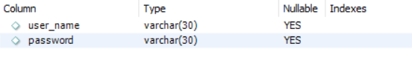

Above is the schema of the **“login_info”** table:

* **user_name:** User Name will be stored in this field for each **Admin** that is assigned to manage the products.
* **password:** Password associated with each user to access the panel.
* **Product table**

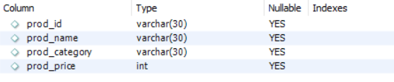

Above is the schema of the **“product”** table:

* **prod_id:** The unique product id associated with each product that is added by the admin
* **prod_name:** Name of the product
* **prod_category:** Category of the product to which it belongs.
* **prod_price:** Price associated with each product.

**Data Flow**



**User Interface**

**Login Page:**

* **Username & Password:** Both required fields will be fetched from the database if the credentials are correct then one will be directed to the **home page** else the wrong will be redirected to an **error page.**

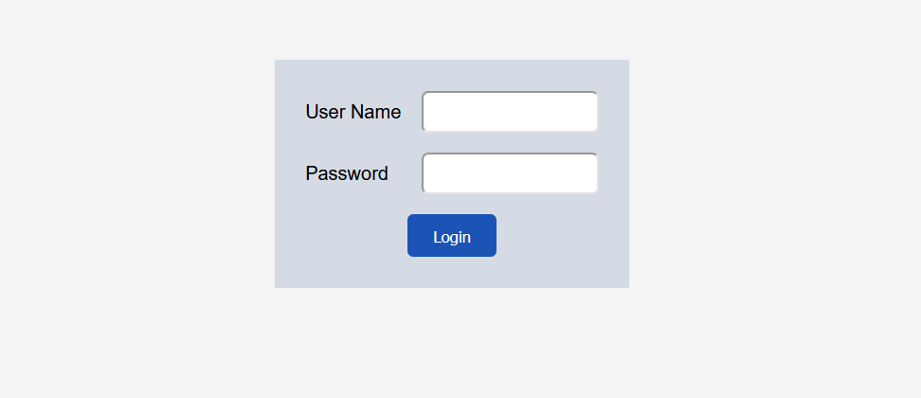

**Error page:** When the credentials are wrong this page will be redirected.

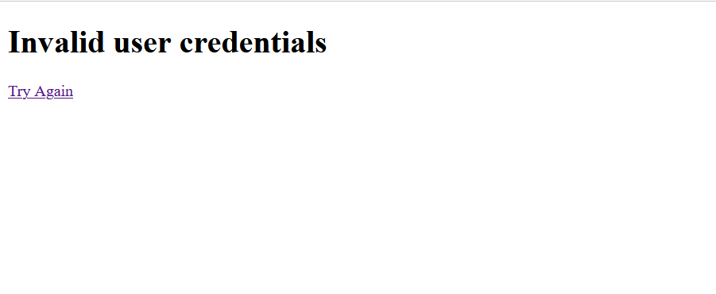

**Home page:** When the credentials are matched with what is saved in the **login_info** table.

**Navigations:**

* **Add Product:** When Admin wants to **add new products** to the database.
* **View Product:** To **view all the products** that are stored by far in the database.
* **Search Product:** For searching products from its **product id**.
* **Logout:** If one wants to log out from the **current session**.

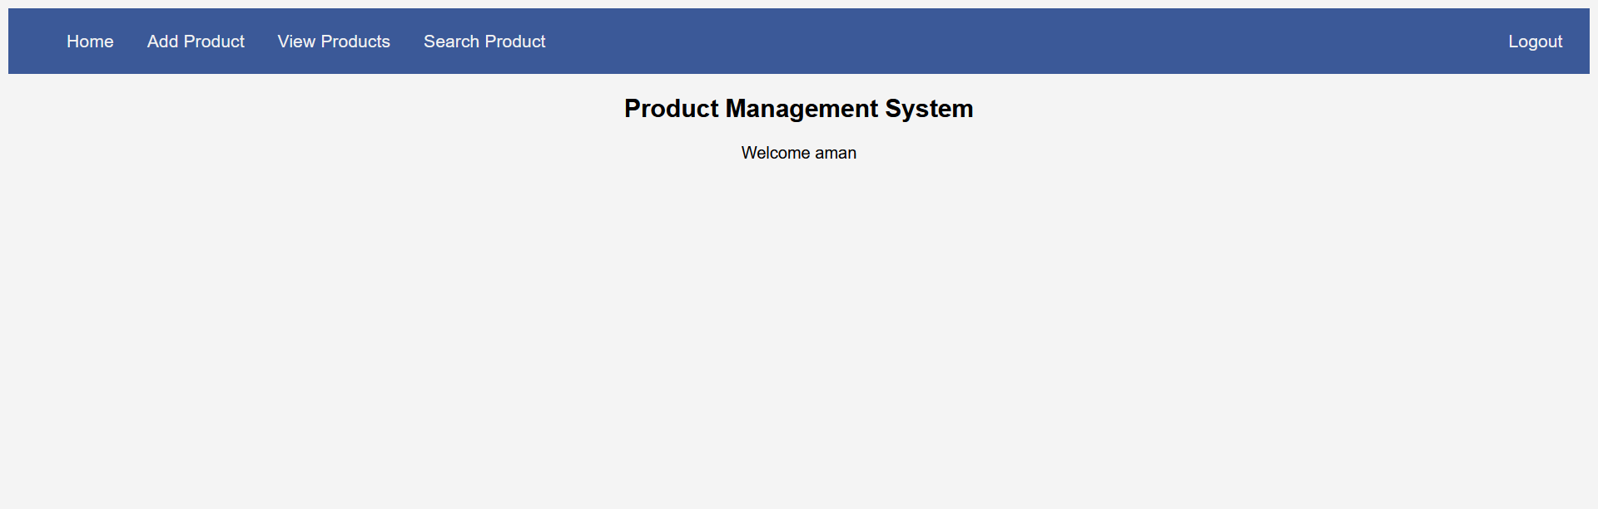

**Add Product:**

**Fields:** Product ID, Product Name, Category of the product, Price of the product

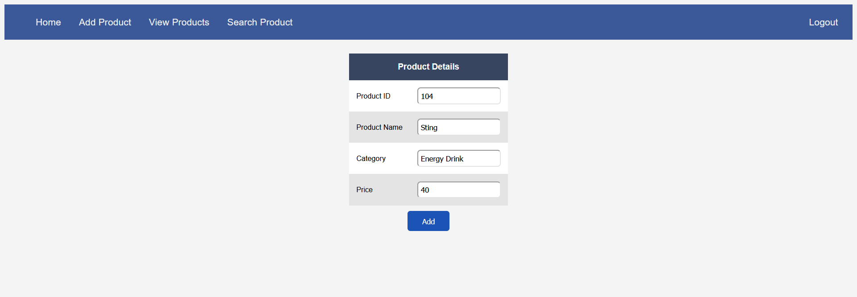

**View Product:**

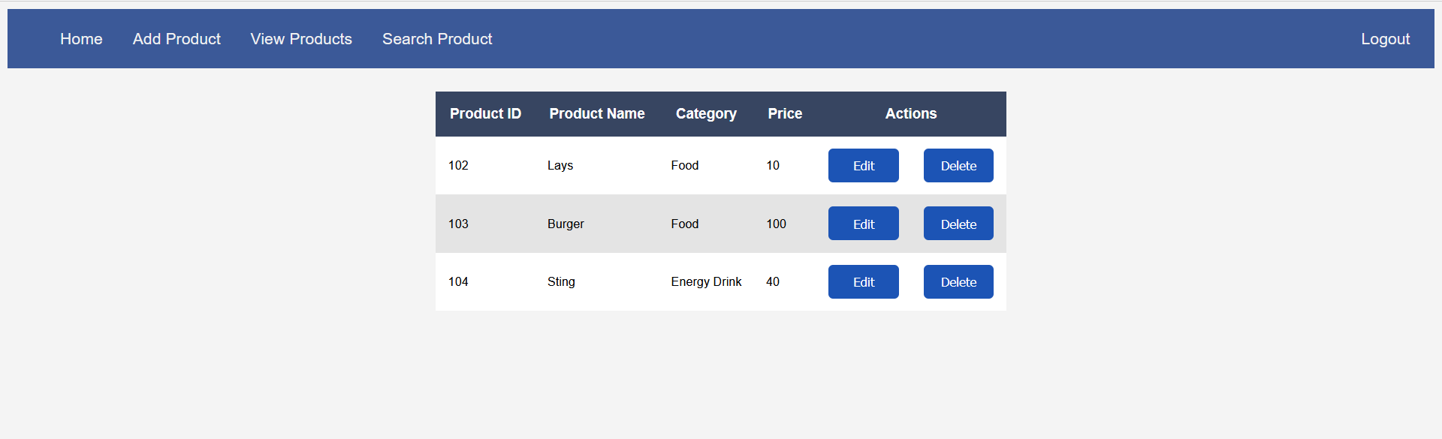

**Update Product:**

For updating the product, we just need to click on the edit option and it will redirect to the below screen where we can change **any** of the **product fields** other than its **ID,** as we are changing the existing product.

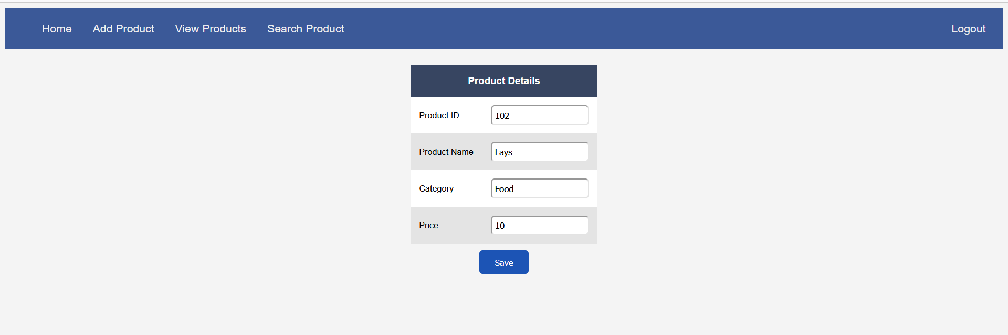

**Note:** We can simply delete any product by clicking on the **Delete button** corresponding to the product that we want to delete it will just update the **“View all products”** page where you won’t find that particular record.

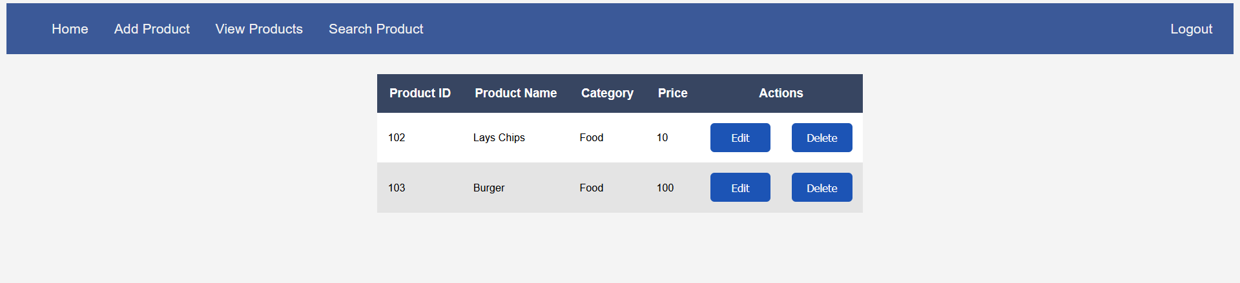

As one can notice that the number of products is updated now.

**After Logout:** We will be re-directed to the Login page.

